Name:__________________________ Date:___________
Biochemistry recognition of key features
Look at the following images or descriptions and determine which biomoluecule each is associated with. Next to each of the diagrams explain
- What are the types of 4 main organic molecules?

Part I. Next to each image tell which biomolecule it is representing or a part of, then explain why you know.
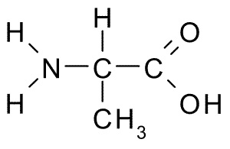
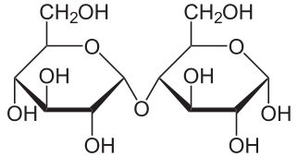

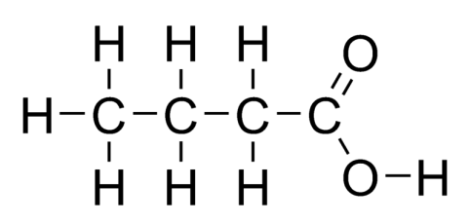
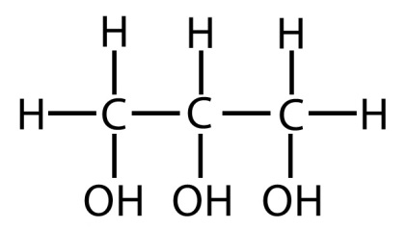
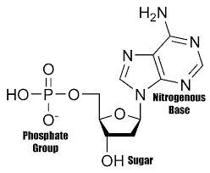
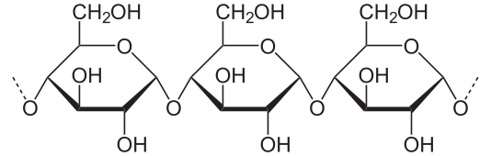

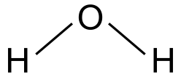
Part II. Answer the questions about each image.
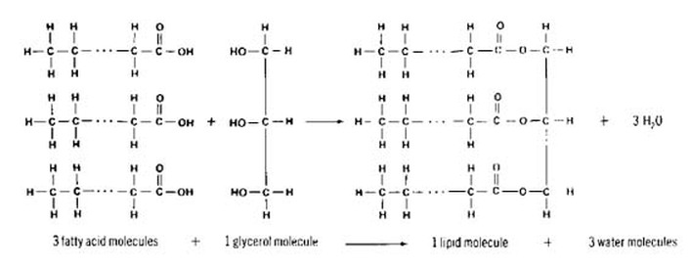
- Label each of the molecules above.
- What chemical process is shown in this diagram?
- State one purpose or use in organisms for this particular biomolecule.

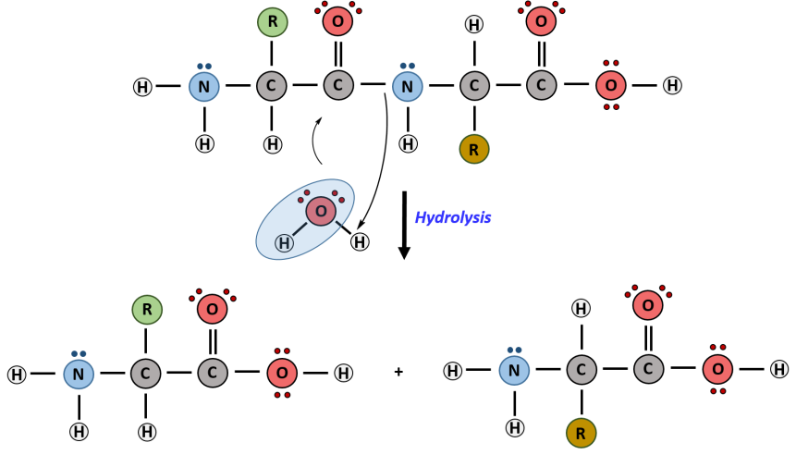

- What biomolecule is shown in the diagram above?
- What chemical process is shown in this diagram?
- State one purpose or use in organisms for this particular biomolecule

