Name:____________________ Date:_____________
A Whale Evolutionary Tale
Background: Whales are mammals that live in the ocean, but just how/when did they evolve to be suited to an aquatic ecosystem? While the answer of how will have to wait we can at least observe the progression of several transitional species, which at the very least share a common ancestor with the modern whale.
The time is 65 million years ago, just after the dinosaurs went extinct and a new class of animals, the mammals; develop very rapidly in evolutionary terms over the next 10-15 million years. Some 130,000 species evolve and diverge from their shared common ancestors; many of which go extinct. However, after using both geologic and organic evolutionary evidence scientists have developed the “Tree of Life”.
The evidence:
- Whale transitional species fossils
- Whale transitional species descriptions of discoveries from fossil sites.
- DNA/molecular evidence from modern species
- A cladogram showing the evolutionary history and when certain groups of mammals diverged from a common ancestor.
Your Task:
- View and discuss the videos about whale fossil discoveries, radiometric dating, and the evidence of evolution.

- Complete the “Whales in the making” graphic organizer using available resources.

- As a group make a phylogenetic tree (with a timeline to scale) of the evolutionary history of the whale and its closest living relatives beginning ~65million years ago.
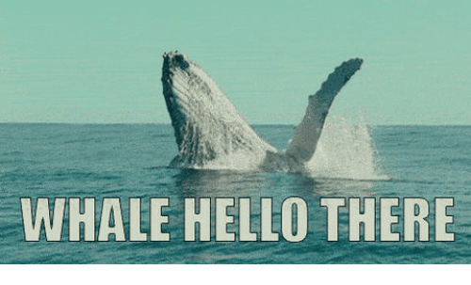
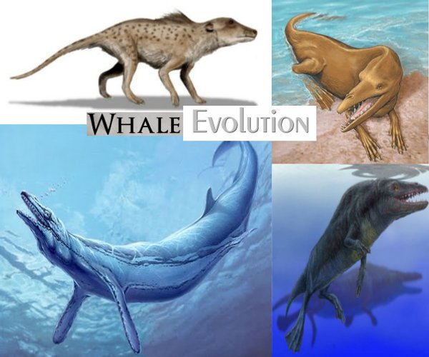
ANCESTORS

Task A. Complete these questions based on our class discussions and the video.
Part I Fossil Formation
Video #1 Becoming A fossil As you watch think about
- How are fossils formed?

- How do scientists determine the age of fossils?

Video #2 Radiometric Dating
- What is radioactive element is used in radiometric dating?

- How is this method of dating fossils different from relative dating?

Part 2: Evidence of the Evolutionary Process
Video #3 Early Tetrapod How the first Fish "walked"
- Discuss the ways in which our current understanding of early tetrapod evolution differs from the traditional view, and explain why this is important.

Video #4 Evolving Ideas: How Do We Know Evolution Happened?
- Using the words homologous and analogous discuss the similarities and differences between whale flippers and fish fins.

Part B. Whale in the Making

Directions: Fill out the Whale in the Making Organizer based on the reading “The Evolution of the Whale” and “Whale in the Making” images of the transitional species of whale. Both are attached to the back of this lab.

****None of these animals are necessarily a direct ancestor of the whales we know today; they may be side branches of the family tree. But the important thing is that each fossil whale shares new, whale-like features with the whales we know today, and in the fossil record, we can observe the gradual accumulation of these aquatic adaptations in the lineage that led to modern whales.

After completing the organizer answer these questions.
- What typical whale-like traits were apparently the earliest to appear? What apparently evolved much later?
_
- To find fossil evidence to fill the largest remaining gap in whale evolution, what age sediments would you search?

- What distinguishing traits would you expect to find in whale fossils of that age?
_

Part C. Now it is time to make a phylogenetic Tree of Whale Evolution.
Materials: meter stick, poster paper, colored pencils, species pictures and the Mammalian Cladogram (attached to lab).
Directions:
Making A Scale
- Hold the paper vertically and draw a vertical line 4cm from the left side of the paper.
- Label at the very bottom of the page just to the left of this line “65mya”.
- Using a meter stick mark off every 1cm on your vertical line till you get to 56cm.
- Label the first line “55 mya” Note this scale jumps from 65mya to 55mya for the first centimeter only.
- Complete the remainder of the scale by using the ration 1cm= 1mya.
- Draw a horizontal line at time “0”.
Completing the Cladogram
- Use the Mammalian Cladogram to start making a phylogentic tree starting at 65 mya and the ancestral shrew at the 25cm point from the left side of the paper.
Your Phylogenetic Tree should:
- Be accurate in when species or groups of species diverged
- Show which organisms are extinct and which are still present today.
- Have color pictures (provided) of the organisms glued onto the poster
- Have DNA comparisons of modern species to the modern whale listed at the top of the page (use the cladogram provided to get info)
- A heading of “The Phylogenetic Tree of Whales”

******Answer the conclusion questions on the next page.

Concluding Questions: Answer in complete sentences.
- Predict why it took 2 million years of evolution to transition from ambulocetus to Rodhocetus, but took 9 million years to transition from Rodhocetus to Basilosaurus.
_

- How do scientists use a combination of organic and geologic evolution to put together the phylogenetic tree of modern whales? Use absolute dating, relative dating, homologous structures and DNA in your answer. *bonus point if you use geologic time scale
_

MODERN BALEEN WHALE

