Name _________________________________ Date Due:
Algebra Regents Review #9
Directions: Choose the best answer. Answer ALL questions. Show ALL work in column 2. If there is no mathematical work to be shown, write an explanation or definition to support your answer!
- Write the expression 5x + 4x²(2x + 7) − 6x² − 9x as a polynomial in standard form.
- Given that a > b, solve for x in terms of a and b: b(x − 3) ≥ ax + 7b
- Given that f(x) = 2x + 1, find g(x) if g(x) = 2[f(x)]²− 1

- A part of Jennifer’s work to solve the equation 2(6x² – 3) = 11x² – x is shown below.
Given: 2(6x² – 3) = 11x² – x
Step 1: 12x² – 6 = 11x² – x
Which property justifies her first step
- identity property of multiplication
- multiplication property of equality
- commutative property of multiplication
- distributive property of multiplication over subtraction
- The cost of airing a commercial on television is modeled by the function C(n) = 110n + 900, where n is the number of times the commercial is aired. Based on this model, which statement is true?
- The commercial costs $0 to produce and $110 per airing up to $900.
- The commercial costs $110 to produce and $900 each time it is aired.
- The commercial costs $900 to produce and $110 each time it is aired.
- The commercial costs $1010 to produce and can air an unlimited number of times.
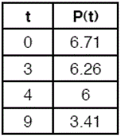
  - The table below represents the height of a bird above the ground during flight, with P(t) representing height in feet and t representing time in seconds. Calculate the average rate of change from 3 to 9 seconds, in feet per second.

  - Which pair of equations could not be used to solve the following equations for x and y?
4x + 2y = 22
–2x + 2y = –8
- 4x + 2y = 22 3. 8x + 4y = 44
2x – 2y =8 –8x + 8y = –8
- 4x + 2y = 22 4. 12x + 6y = 66
–4x + 4y = –16 6x – 6y = 24
  - The table below represents the function F.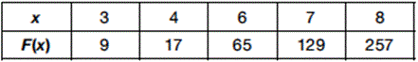
The equation that represents this function is
- F(x) = 3^{x}
- F(x) = 3x
- F(x) = 2^{x} + 1
- F(x) = 2x + 3
  - The range of the function defined as y = 5^{x} is
- y < 0 3. y > 0
- y ≤ 0 4. y ≥ 0
  - Compared to the graph of f(x) = x², the graph of g(x) = (x − 2)² + 3 is the result of translating f(x)
- 2 units up and 3 units right
- 2 units down and 3 units up
- 2 units right and 3 units up
- 2 units left and 3 units right
  - Which statement is not always true?
- The product of two irrational numbers is irrational.
- The product of two rational numbers is rational.
- The sum of two rational numbers is rational.
- The sum of a rational number and an irrational number is irrational.
  - Which equation is equivalent to y − 34 = x(x − 12)?
- y = (x − 17)(x + 2)
- y = (x − 17)(x − 2)
- y = (x − 6)² + 2
- y = (x − 6)² – 2
  - If y = 3x³ + x² − 5 and z = x² − 12, which polynomial is equivalent to 2(y + z)?
- 6x³ + 4x² − 34
- 6x³ + 3x² − 17
- 6x³ + 3x² − 22
- 6x³ + 2x² − 17
  - Which equation has the same solution as x² − 6x − 12 = 0?
- (x + 3)² = 21
- (x − 3)² = 21
- (x + 3)² = 3
- (x − 3)² = 3
  - What are the roots of the equation x² + 4x - 16 = 0?
- 3.
- 4.

16) Which of the three situations given below is best modeled by an exponential function?
I. A bacteria culture doubles in size every day.
II. A plant grows by 1 inch every 4 days.
III. The population of a town declines by 5% every 3 years.
- I, only 3. II, only
- I and II 4. I and III
  - The length, width, and height of a rectangular box are represented by 2x, 3x + 1, and 5x − 6, respectively. When the volume is expressed as a polynomial in standard form, what is the coefficient of the 2nd term?
- −13
- 13
- −26
- 26
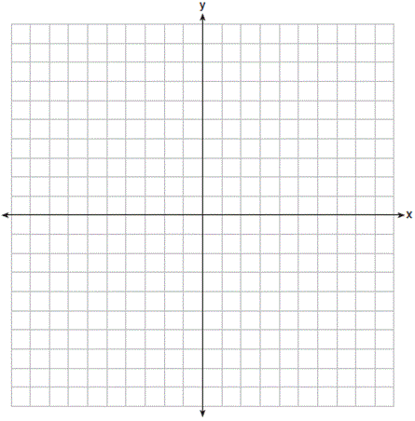
18) a. On the set of axes below, draw the graph of the equation y = $\frac{-3}{4}$x + 3.
b. Is the point (3, 2) a solution to the equation? Explain your answer based on the graph drawn.

19. The Utica Boilermaker is a 15-kilometer road race. Sara is signed up to run this race and has done the following training runs:
I. 10 miles
II. 44,880 feet
III. 15,560 yards
Which run(s) are at least 15 kilometers?
- I, only
- II, only
- I and III
- II and III
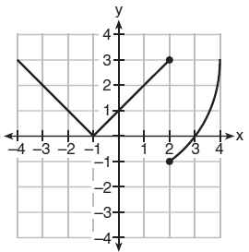
Marcel claims that the graph below represents a function. State whether Marcel is correct. Justify your answer.

