Studio in Photography
Mr. Martin
Assignment #7
Special Effects
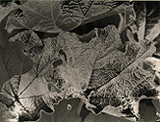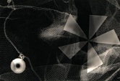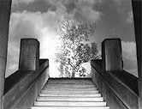
The Special Effects Assignment is an opportunity to take your existing images and to create new ones. The images may push the boundaries of reality, give a new “mysterious” perspective, or simply improve the image with photofinishing. These photographic processes include: darkroom procedures, shooting techniques and photofinishing methods.

Possible Special Effects Include:
Negative Sandwich
Paper Negative
Solarization
Photogram
Multiple Printing
Multiple Exposure
Repeated Image
Sepia Toning
Hand Coloring
Photoshop Effects

