Name_______________
DDP 2015-2016 Midterm Review
Use your class notes to complete the questions below. If you are missing information, review the Power Points on my website under notes and other important information.
The Elements and Principles of Design
The elements of design are used to create the principles of design.
List the elements of design:  1.  2.  3.  4.  5.  6.  7. | List the principles of design:  - Balance – Three types  Symmetry  Asymmetry  Radial  2.  3.  4.  5.  6.

Label the designs geometric or organic.
___________________ | 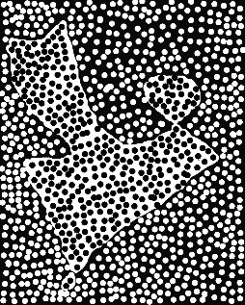 -------------------------------

Name the type of balance used. It should be either symmetry, asymmetry or radial.
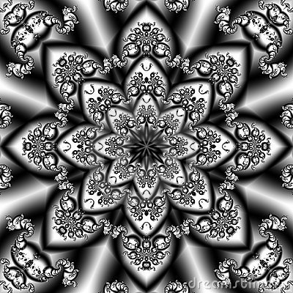  _________________ | 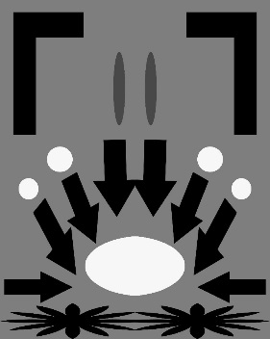  _____________________ | 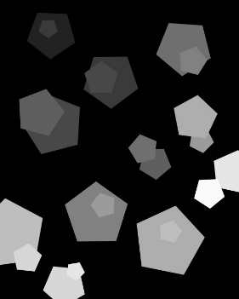  __________________

Complete a quick sketch that illustrates one of the following principles of design.

Emphasis | Unity | Rhythm
Contrast | Proportion

Definition to Review

Harmony - Using elements and principles of design, designers create a sense of harmony. Using repeated colors, lines, shapes and themes, make designs appear unified.

