Name_______________
DDP 2015-2016 Midterm Review
Use your class notes to complete the questions below. If you are missing information, review the Power Points on my website under notes and other important information.
Linear Perspective
Two-Point Perspective One-Point Perspective
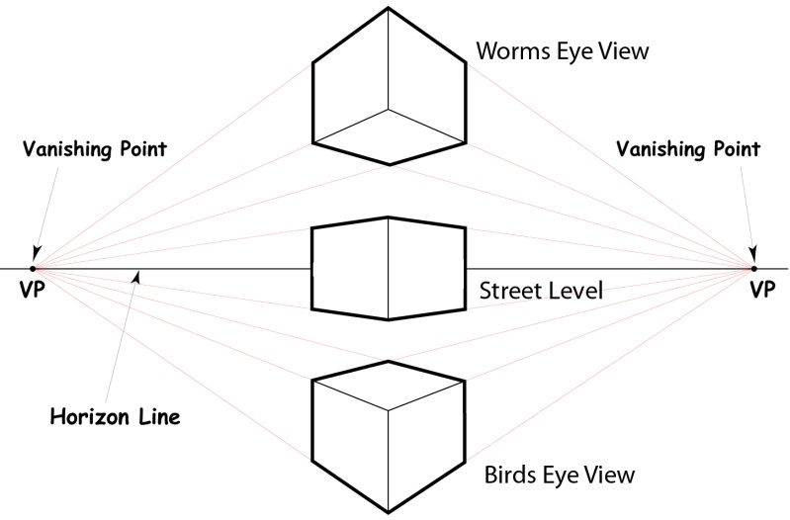 | 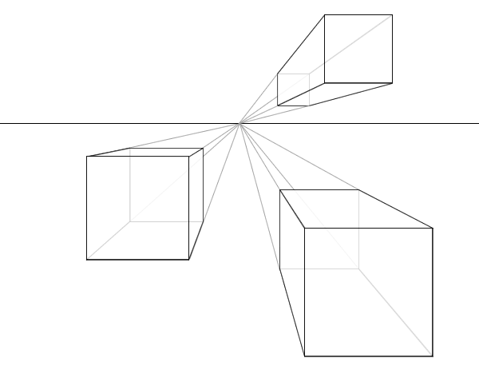

- What is linear perspective?

- Label the vanishing point, horizon line and orthogonal lines on the image below.

Draw a one-point perspective cube below.

Draw a two-point perspective cube below.

